**LFI (Local File Inclusion)**

**Path traversal / Directory traversal**

* **What path traversal is.**
* **How to carry out path traversal attacks and circumvent common obstacles.**
* **How to prevent path traversal vulnerabilities.**

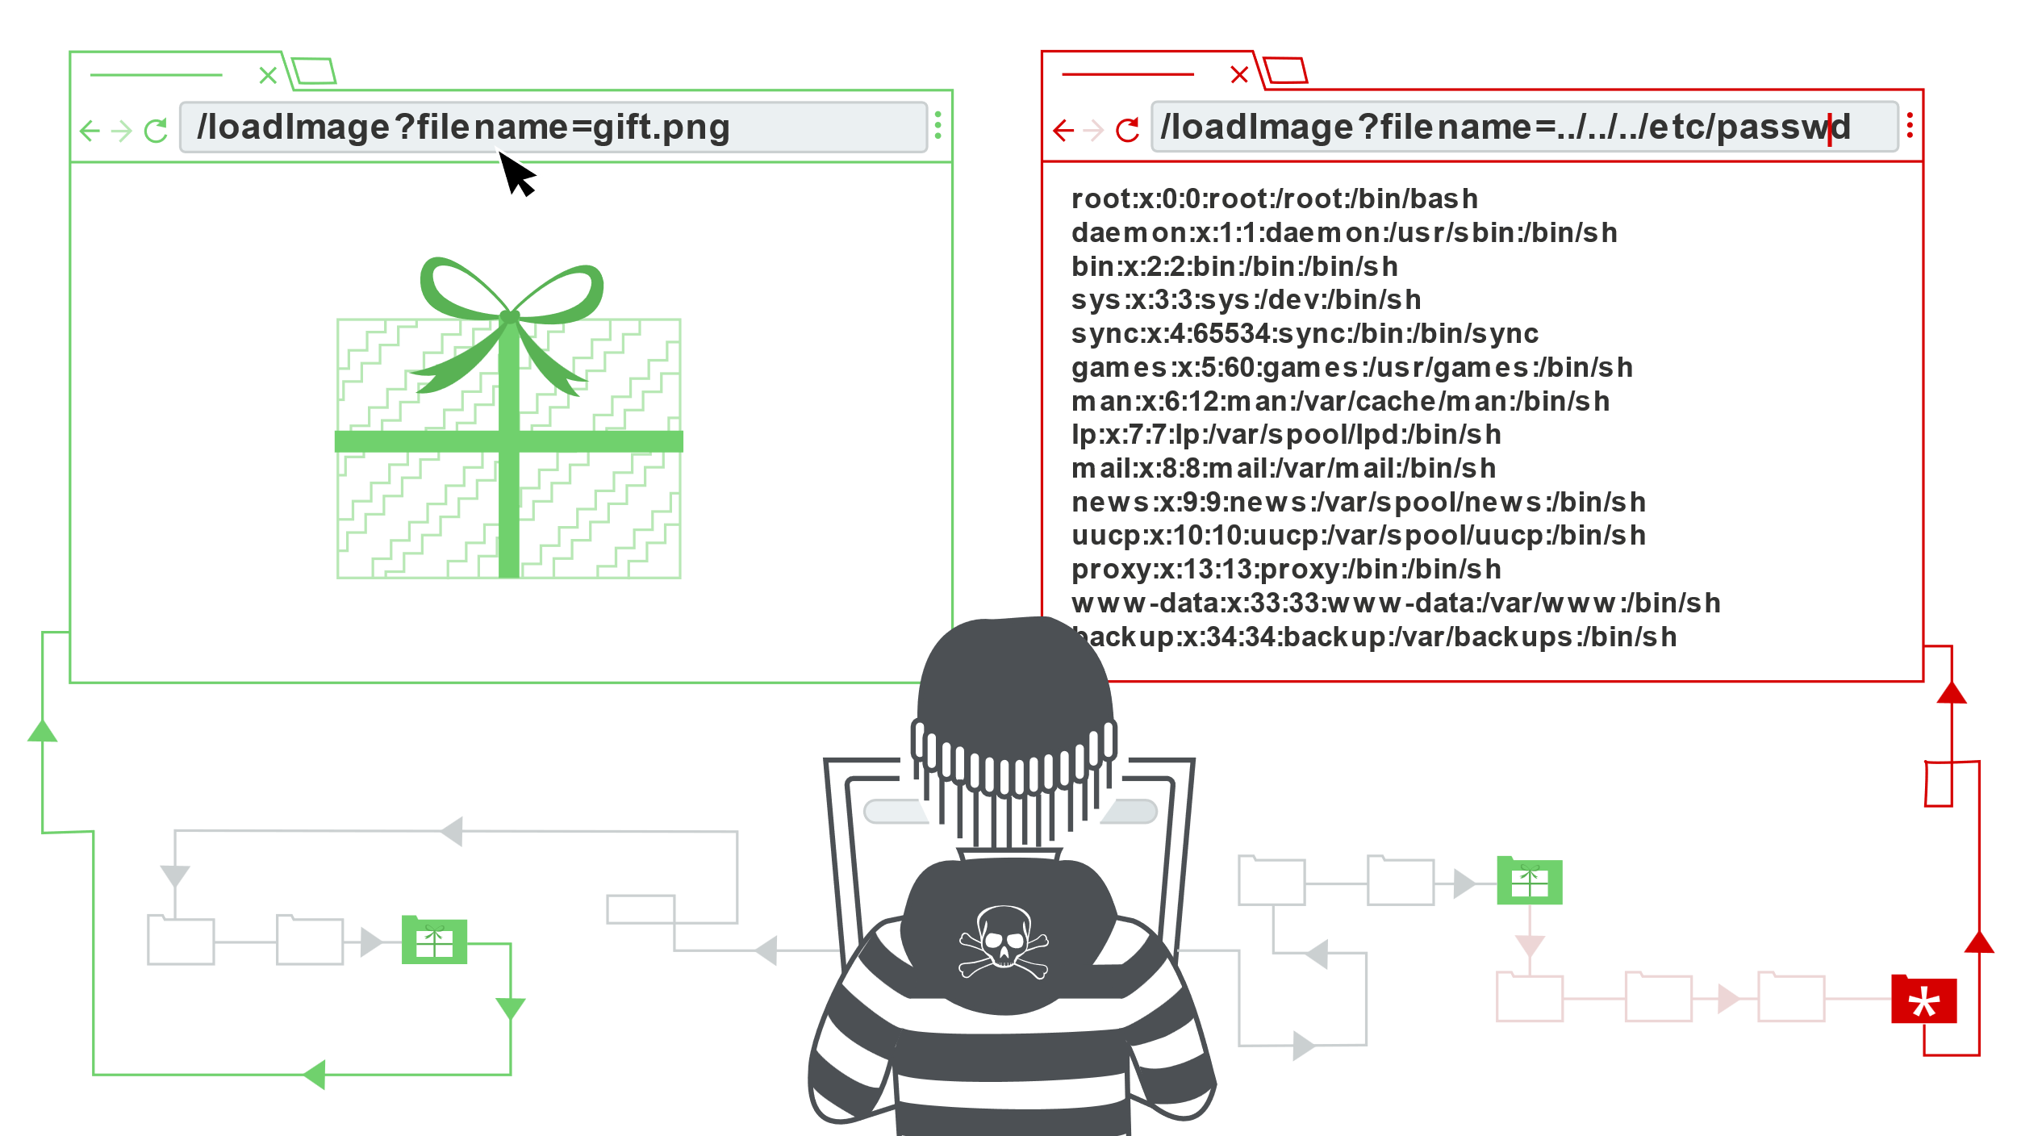

**What is path traversal?**

Path traversal is also known as directory traversal. These vulnerabilities enable an attacker to read arbitrary files on the server that is running an application. This might include:

* Application code and data.
* Credentials for back-end systems.
* Sensitive operating system files.

In some cases, an attacker might be able to write to arbitrary files on the server, allowing them to modify application data or behavior, and ultimately take full control of the server.

**Reading arbitrary files via path traversal**

Imagine a shopping application that displays images of items for sale. This might load an image using the following HTML:

<img src="/loadImage?filename=218.png">

The ***loadImage*** URL takes a *filename* parameter and returns the contents of the specified file. The image files are stored on disk in the location ***/var/www/images/.*** To return an image, the application appends the requested filename to this base directory and uses a filesystem API to read the contents of the file. In other words, the application reads from the following file path:

/var/www/images/218.png

This application implements no defenses against path traversal attacks. As a result, an attacker can request the following URL to retrieve the ***/etc/passwd*** file from the server's filesystem:

https://insecure-website.com/loadImage?filename=../../../etc/passwd

This causes the application to read from the following file path:

/var/www/images/../../../etc/passwd

The sequence ../ is valid within a file path, and means to step up one level in the directory structure. The three consecutive ../ sequences step up from ***/var/www/images/*** to the filesystem root, and so the file that is actually read is:

/etc/passwd

On Unix-based operating systems, this is a standard file containing details of the users that are registered on the server, but an attacker could retrieve other arbitrary files using the same technique.

On Windows, both ../ and ..\ are valid directory traversal sequences. The following is an example of an equivalent attack against a Windows-based server:

https://insecure-website.com/loadImage?filename=..\..\..\windows\win.ini

**Lab: 1. File path traversal, simple case**

(https://portswigger.net/web-security/file-path-traversal/lab-simple)

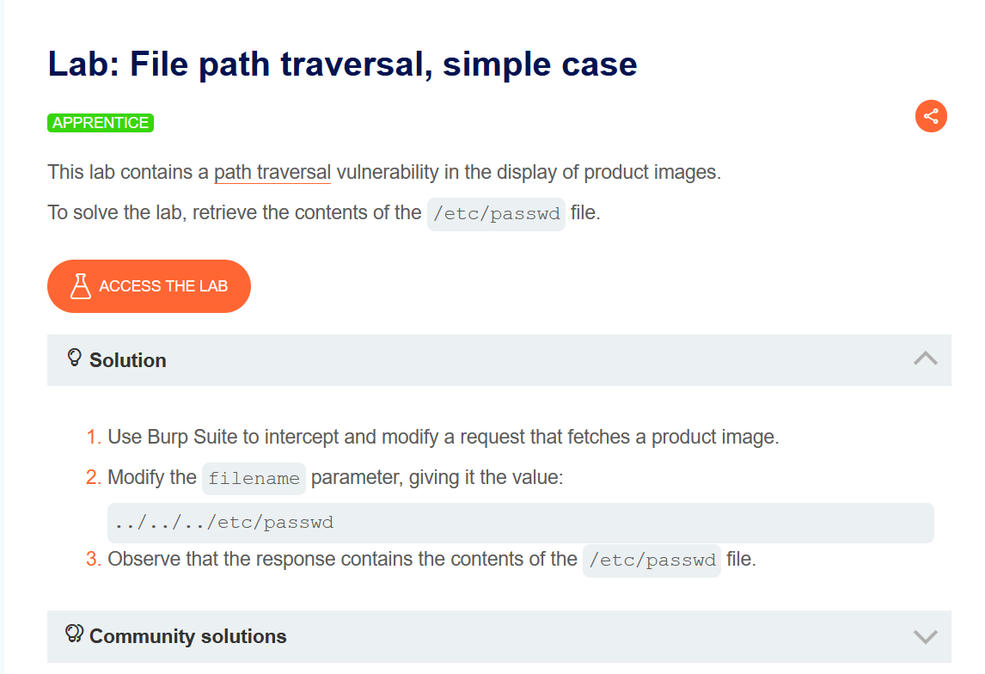

**Let Access the Lab**

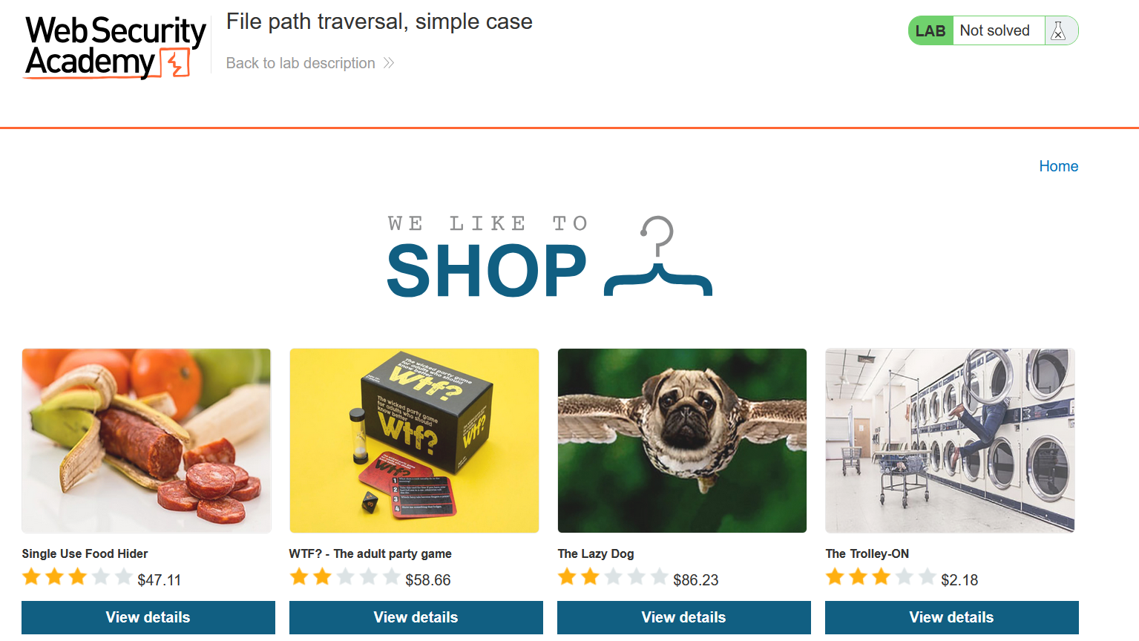

Select any product

Open Burp and tap on product Capture the request

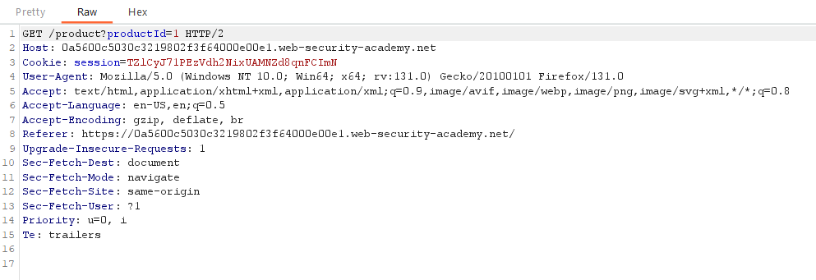

This is productid forward this

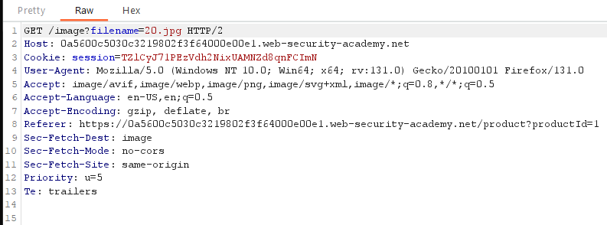Here is the request we are waiting for as we see clearly this request in Get and contain

**/image?filename=20.jpg**

the parameter filename delivering the images can be modify here, we were going to use this to view content of /etc/passwd file**.**

**Forward** this to **Repeater** and **Replace 20.jpg** with **../../../etc/passwd** in request

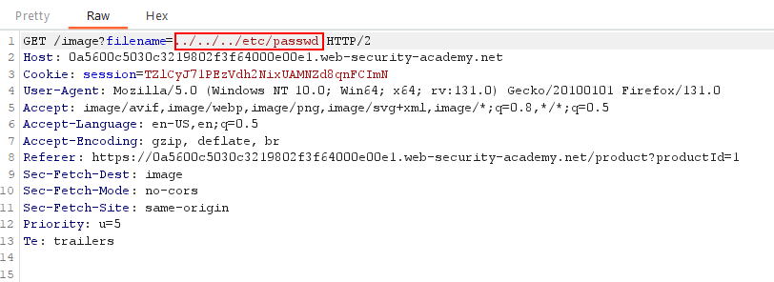

**Forward this**

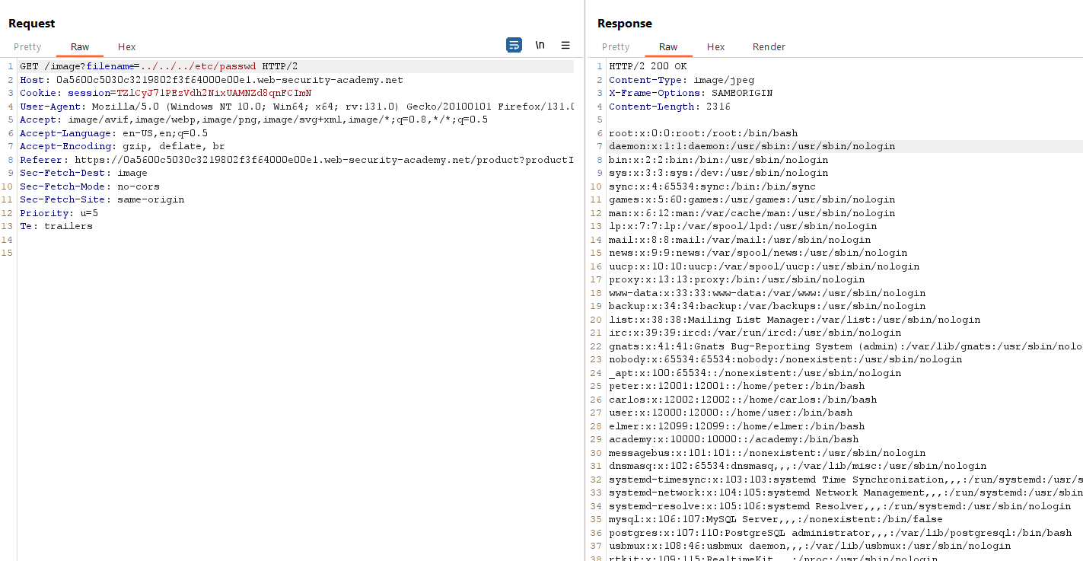

**Success !! just forward this manualy**

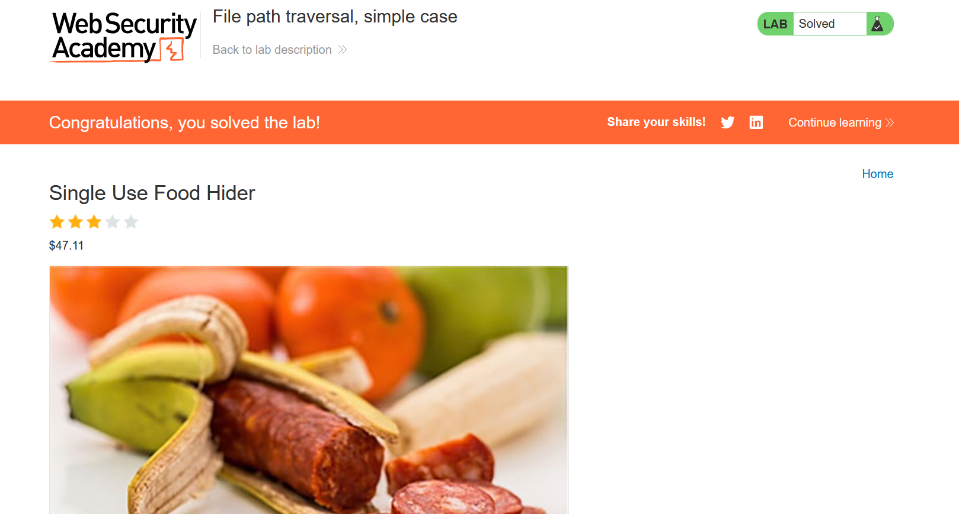

**Done**

**Common obstacles to exploiting path traversal vulnerabilities**

Many applications that place user input into file paths implement defenses against path traversal attacks. These can often be bypassed.

If an application strips or blocks directory traversal sequences from the user-supplied filename, it might be possible to bypass the defense using a variety of techniques.

You might be able to use an absolute path from the filesystem root, such as filename=/etc/passwd, to directly reference a file without using any traversal sequences.

**Lab 2. File path traversal, traversal sequences blocked with absolute path bypass**

**https://portswigger.net/web-security/file-path-traversal/lab-absolute-path-bypass**

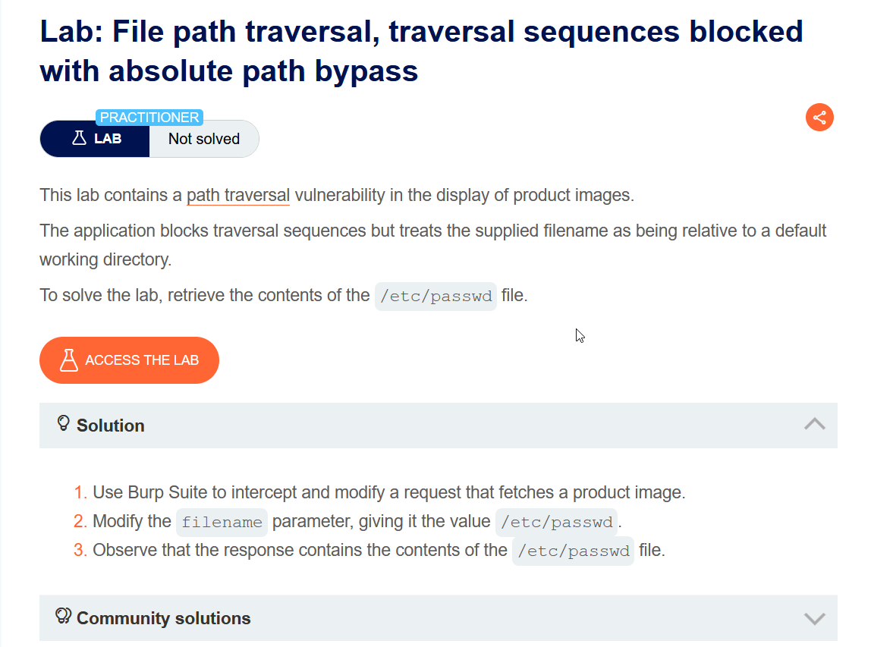

**In this scenario there is application block path traversal but we still can do it, The application only block relative path like ../../**

**But we were going to use direct path like /etc/passwd without ../../**

**Let Access the Lab**

Select any product



Open Burp and tap on product Capture the request

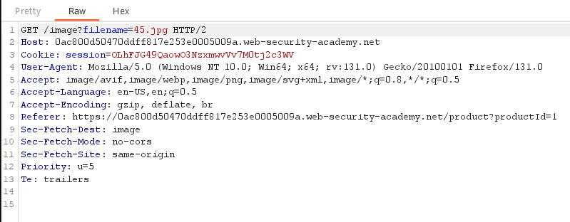

Now send this Request to Repeater and Replace 45.jpg with **/etc/passwd**

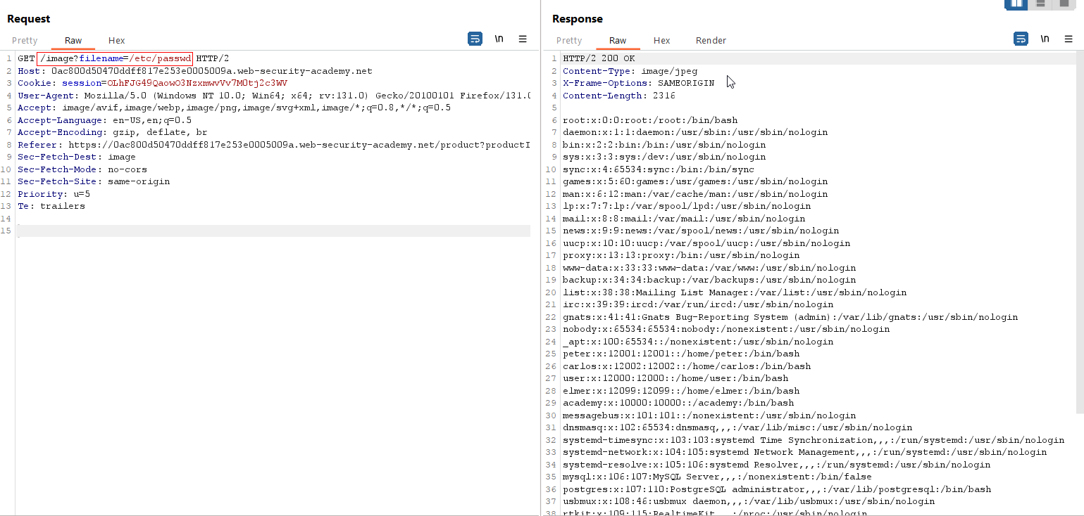

Success

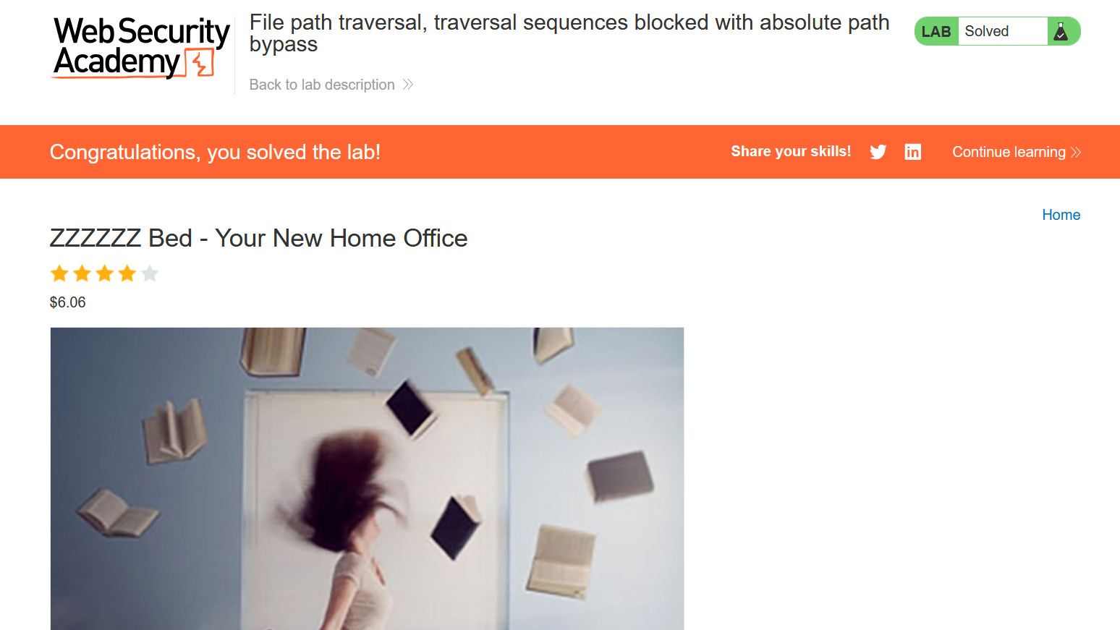

Done

You might be able to use nested traversal sequences, such as ....// or ....\/. These revert to simple traversal sequences when the inner sequence is stripped.

**Lab 3. File path traversal, traversal sequences stripped non-recursively**

<https://portswigger.net/web-security/file-path-traversal/lab-sequences-stripped-non-recursively>

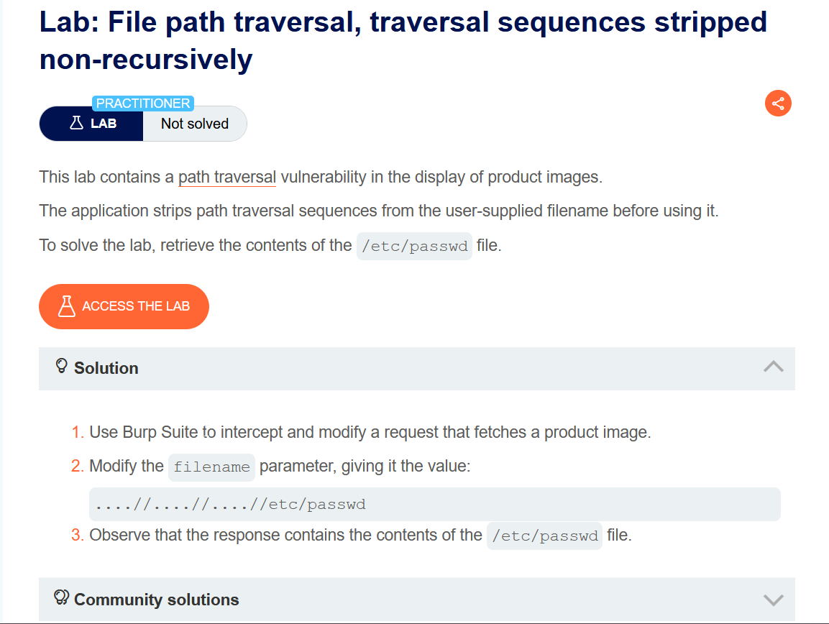

**In this lab Scenario there is a filter that remove ../**

**In order to successfully path traversal, we need to use this format**

**....//....//....// the filter will sort first 2 dot and a slash**

**Let Access the Lab**



select any product and Capture the Request

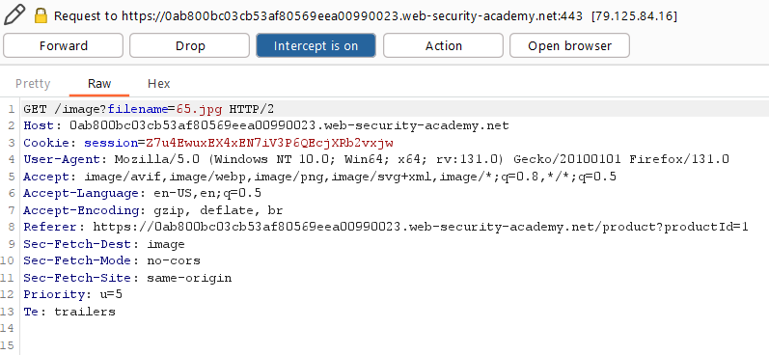

Let send this To repeater and Replace 65.jpg with ....//....//....//etc/passwd

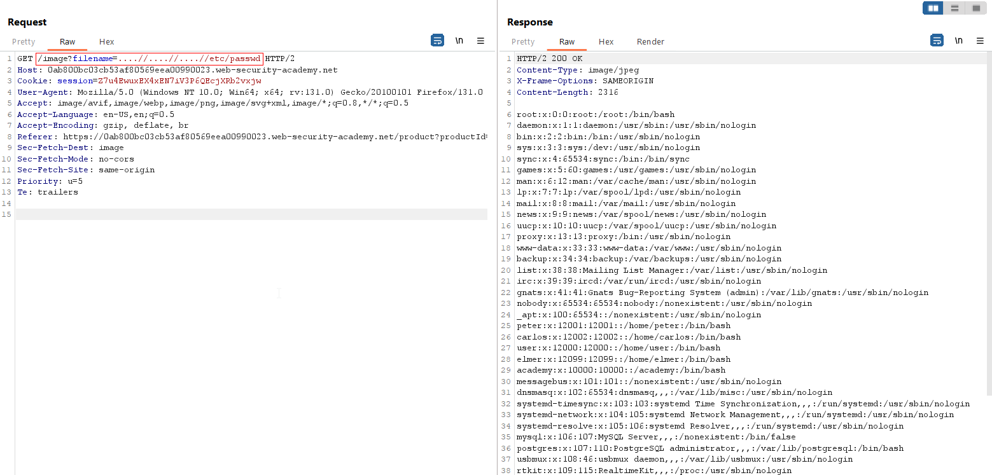

Successfully bypass

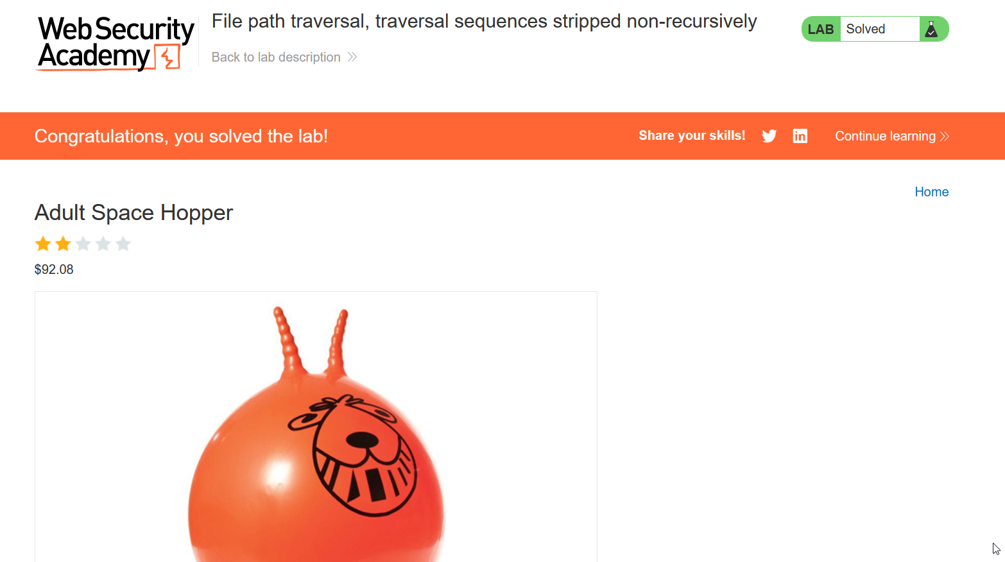Done

In some contexts, such as in a URL path or the ***filename*** parameter of a ***multipart/form-data request***, web servers may strip any directory traversal sequences before passing your input to the application. You can sometimes bypass this kind of sanitization by URL encoding, or even double URL encoding, the ../ characters. This results in %2e%2e%2f and %252e%252e%252f respectively. Various non-standard encodings, such as ..%c0%af or ..%ef%bc%8f, may also work.

For [Burp Suite Professional](https://portswigger.net/burp/pro) users, Burp Intruder provides the predefined payload list **Fuzzing - path traversal**. This contains some encoded path traversal sequences that you can try.

**Lab 4: File path traversal, traversal sequences stripped with superfluous URL-decode**

<https://portswigger.net/web-security/file-path-traversal/lab-superfluous-url-decode>

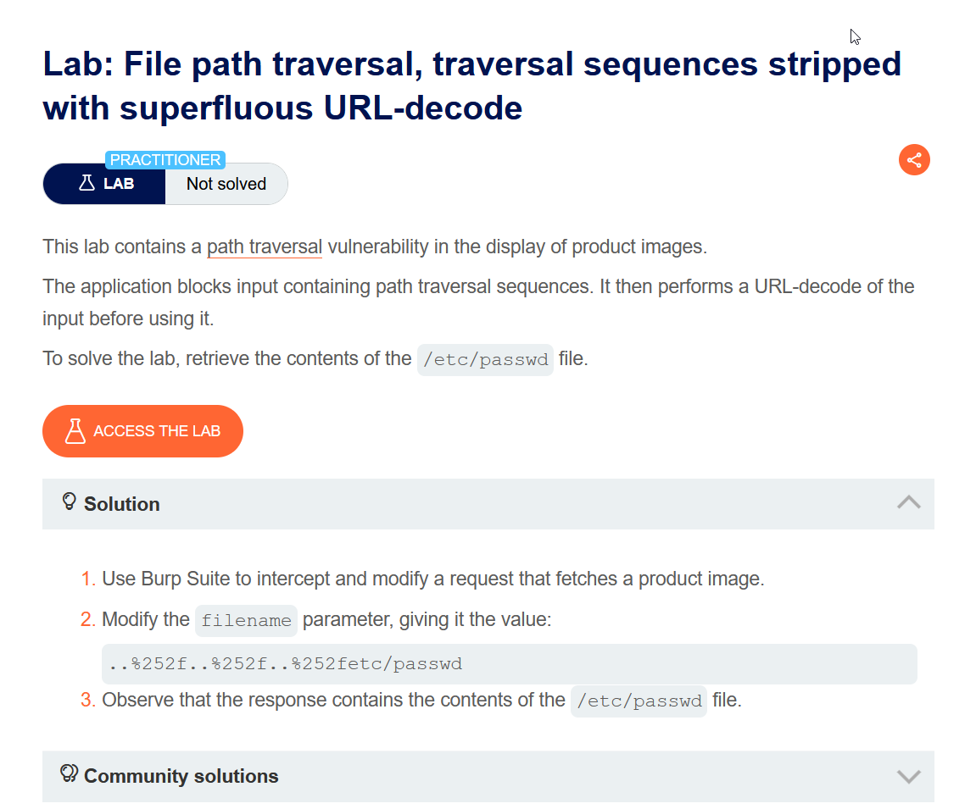

In this lab scenario there is a filter that block ../ we were going to bypass this using URL encoding by encoding / and leaving rest as same

**Let Access the Lab**



Select any product and capture the request

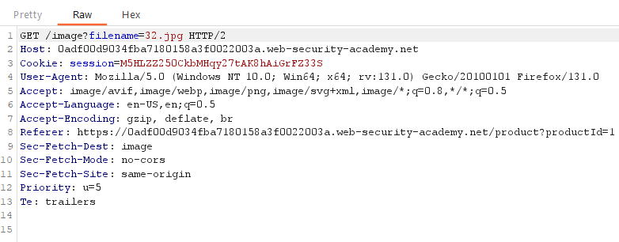

Send this to repeater and Open Decoder tab on burp

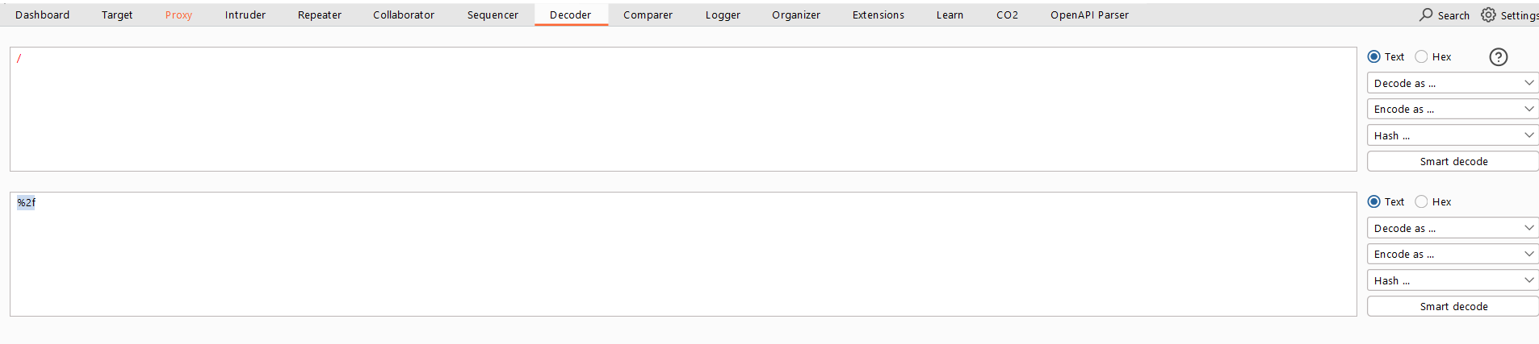

I just encode single slash and we were going to use this format ..%252f..%252f..%252fetc/passwd in this format / are encoded that bypass restriction

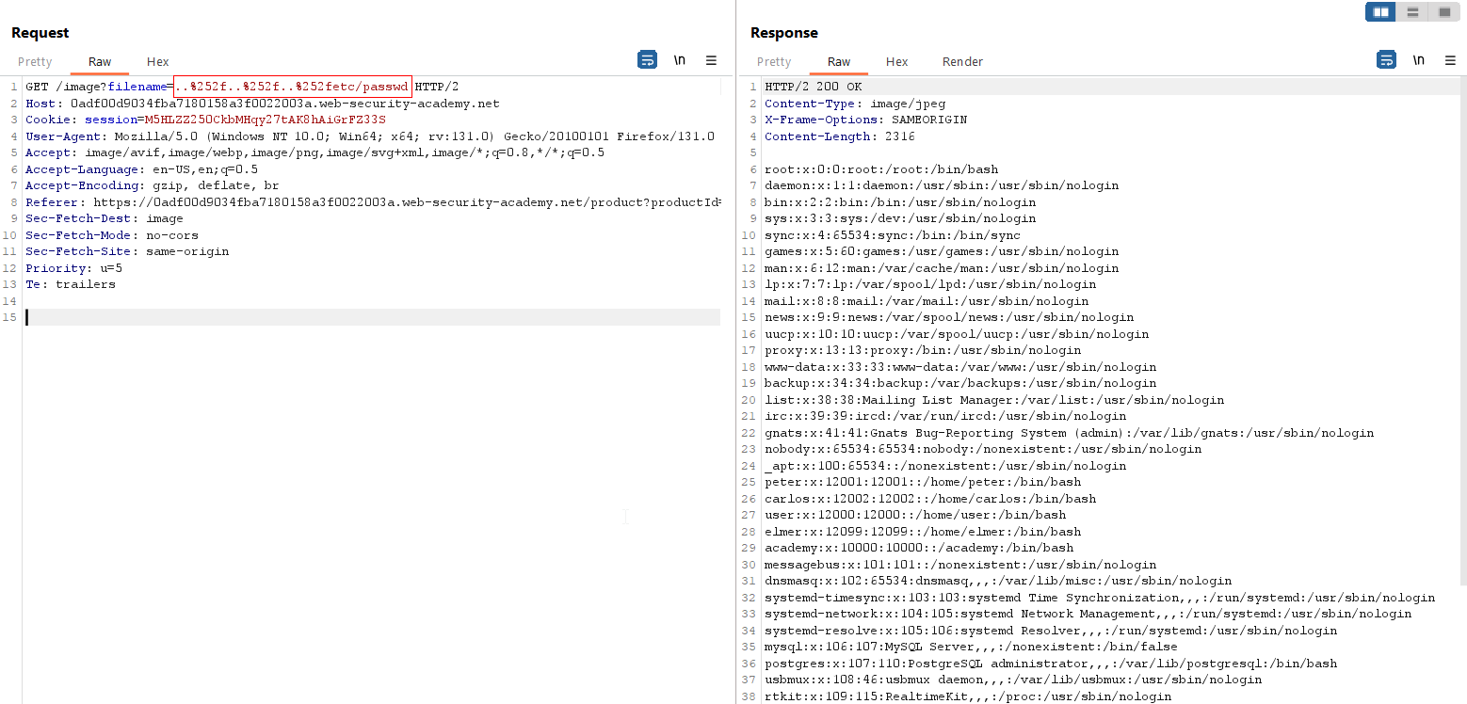

Success

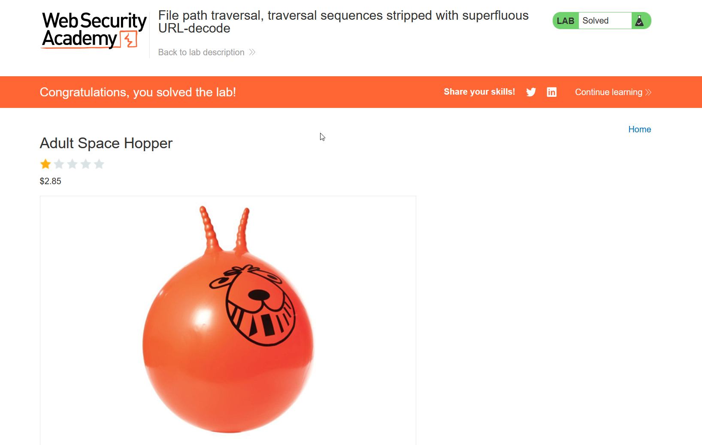

Done

An application may require the user-supplied filename to start with the expected base folder, such as /var/www/images. In this case, it might be possible to include the required base folder followed by suitable traversal sequences. For example: filename=/var/www/images/../../../etc/passwd

**Lab 5: File path traversal, validation of start of path**

<https://portswigger.net/web-security/file-path-traversal/lab-validate-start-of-path>

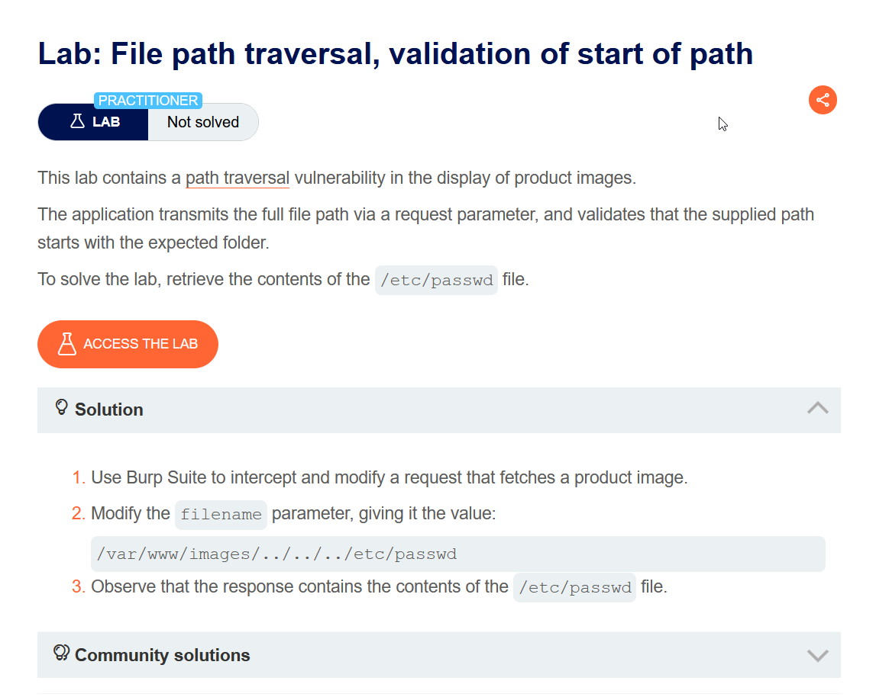

In this lab scenario we need to specify the whole path in order to view etc/passwd

**Let Access the Lab**



Select any product and capture the request

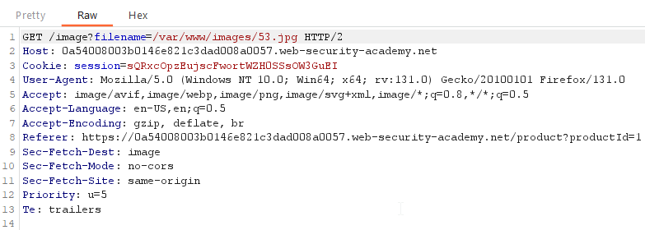

Send this request to repeater and Replace var/www/images/53.jpg with

/image?filename=/var/www/images/../../../../etc/passwd

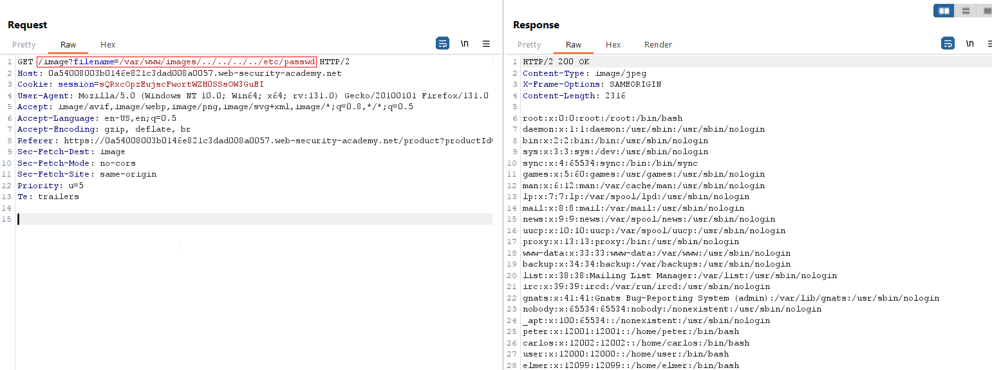

Success

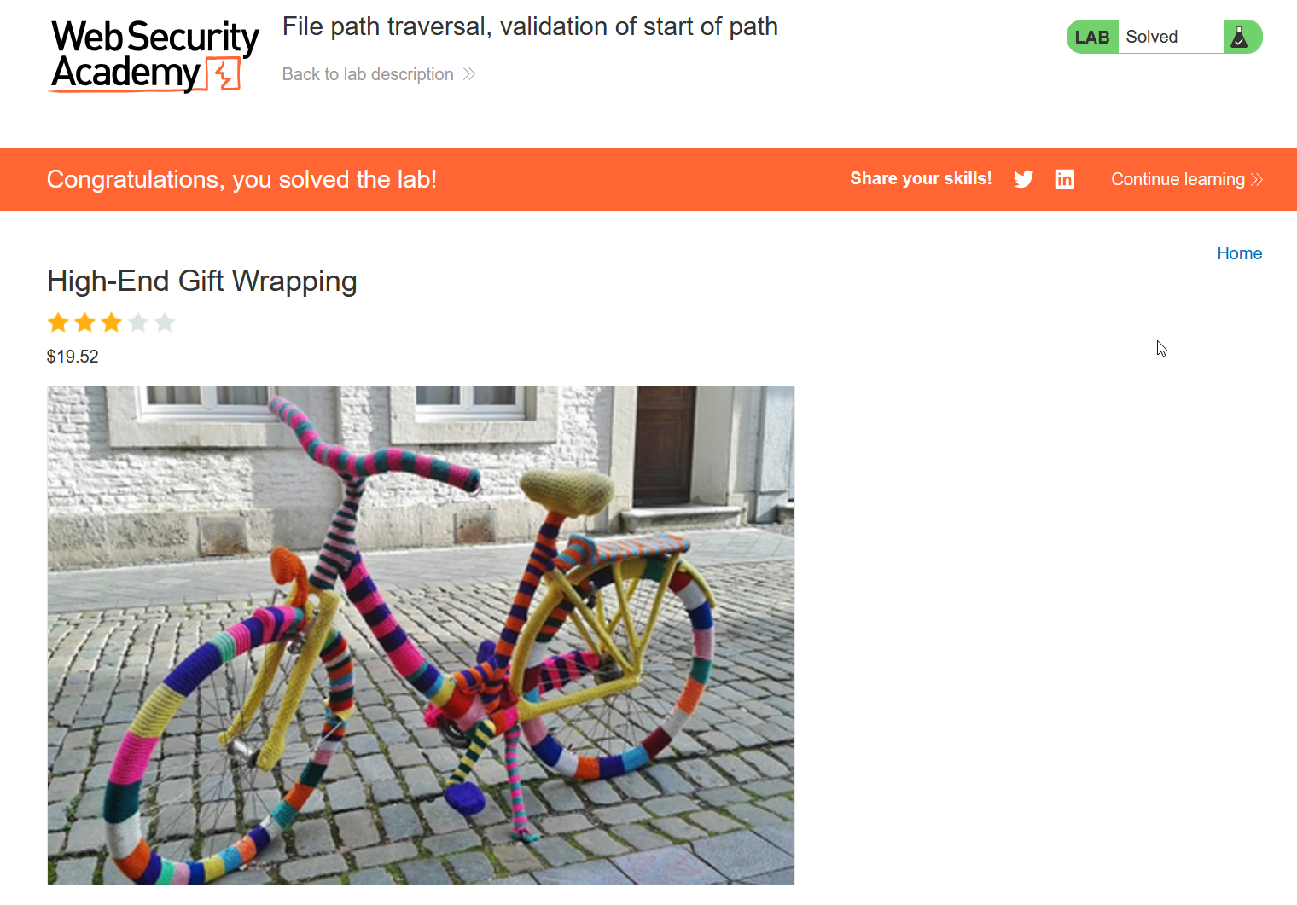

Done

An application may require the user-supplied filename to end with an expected file extension, such as .png. In this case, it might be possible to use a null byte to effectively terminate the file path before the required extension. For example: filename=../../../etc/passwd%00.png.

**Lab 6: File path traversal, validation of file extension with null byte bypass**

<https://portswigger.net/web-security/file-path-traversal/lab-validate-file-extension-null-byte-bypass>

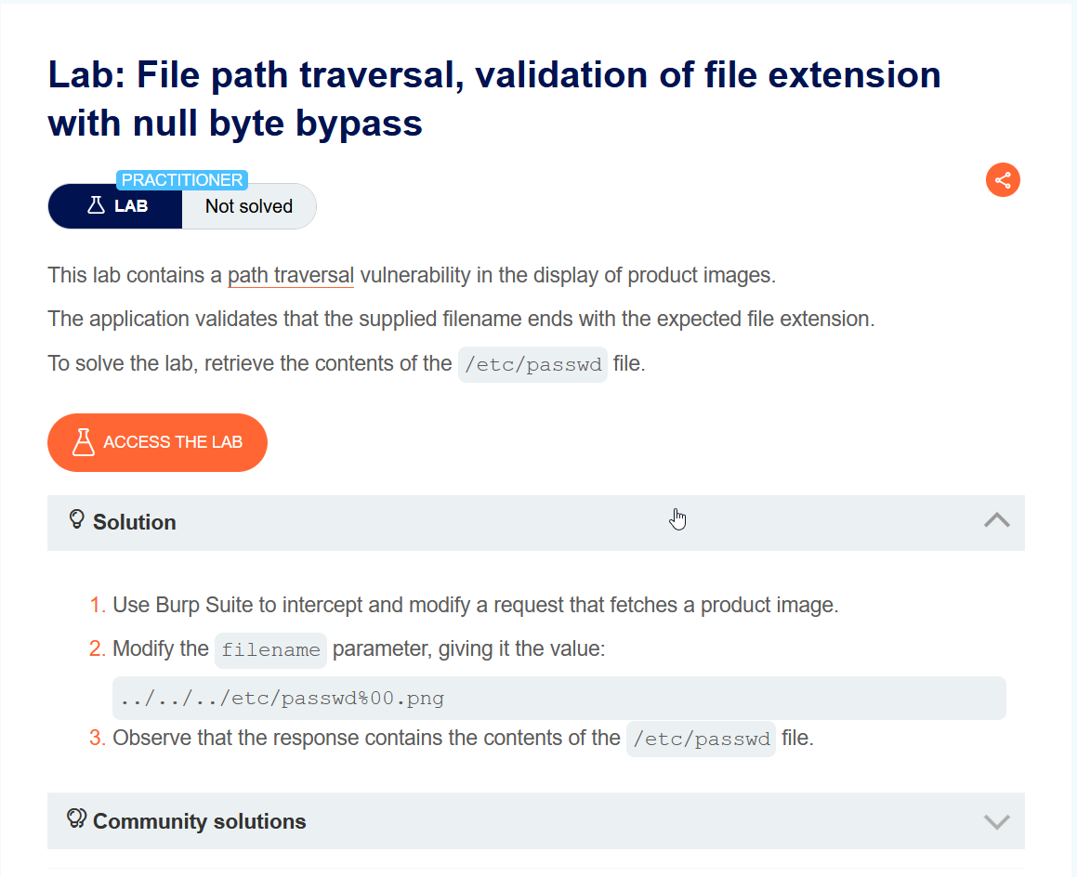

In this lab scenario the web application has a validation In which we need to must end with certain file extension, In order to get /etc/passwd we need to add file extension in end to validate the request.

**Let Access the Lab**

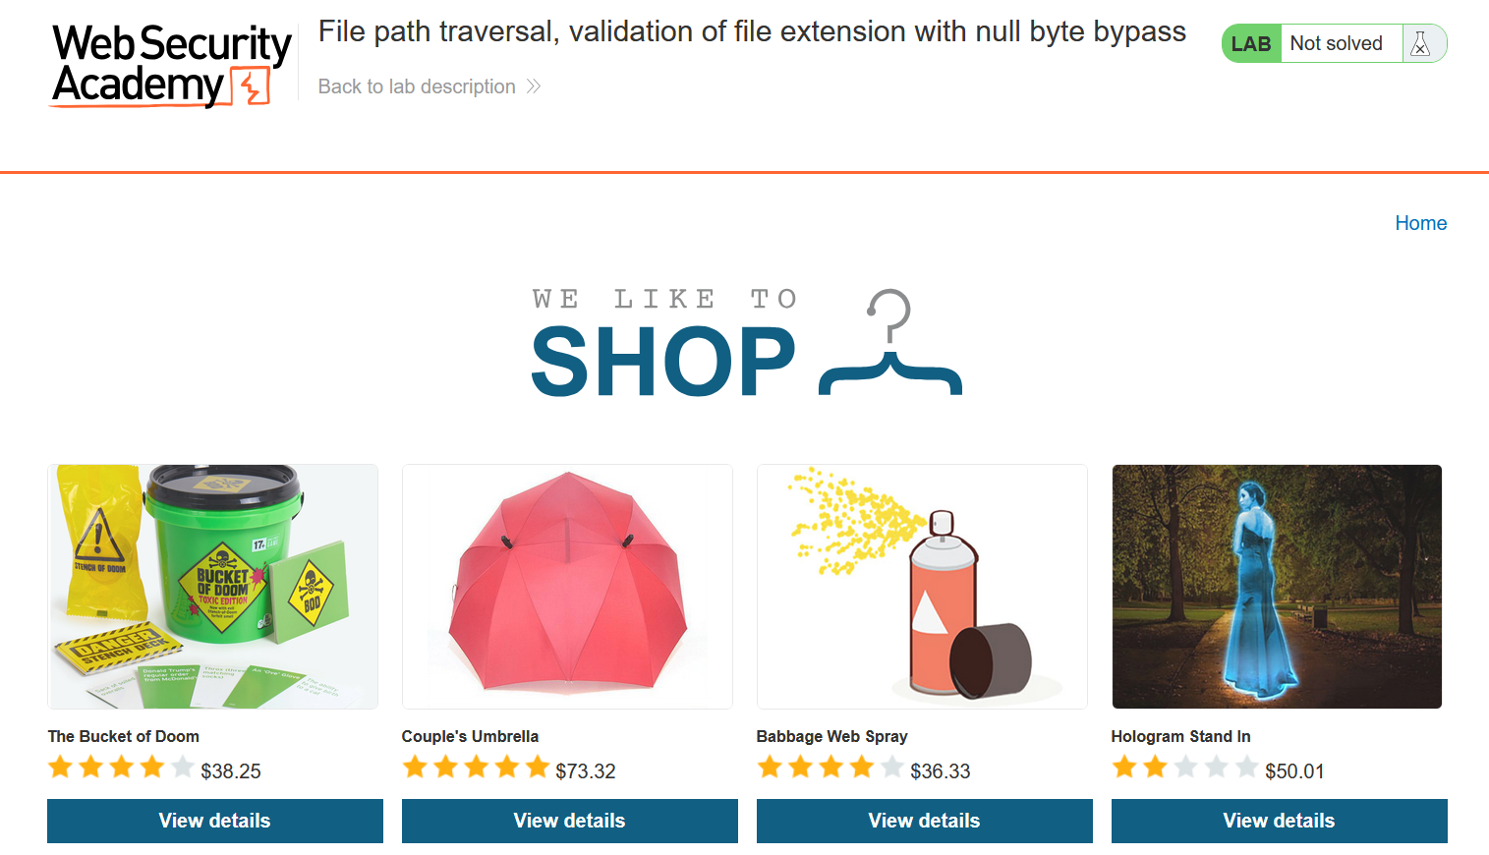

Select any product and capture the request

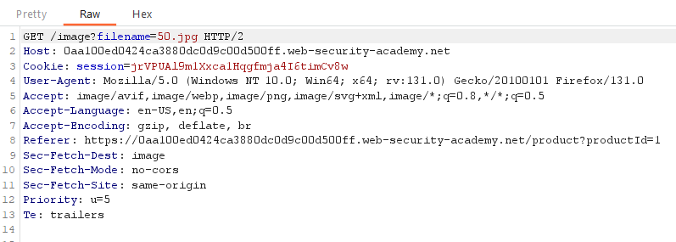

Send this request to Repeater and replace 50.jpg with ../../../etc/passwd%00.png in with %00 is encoding of space.

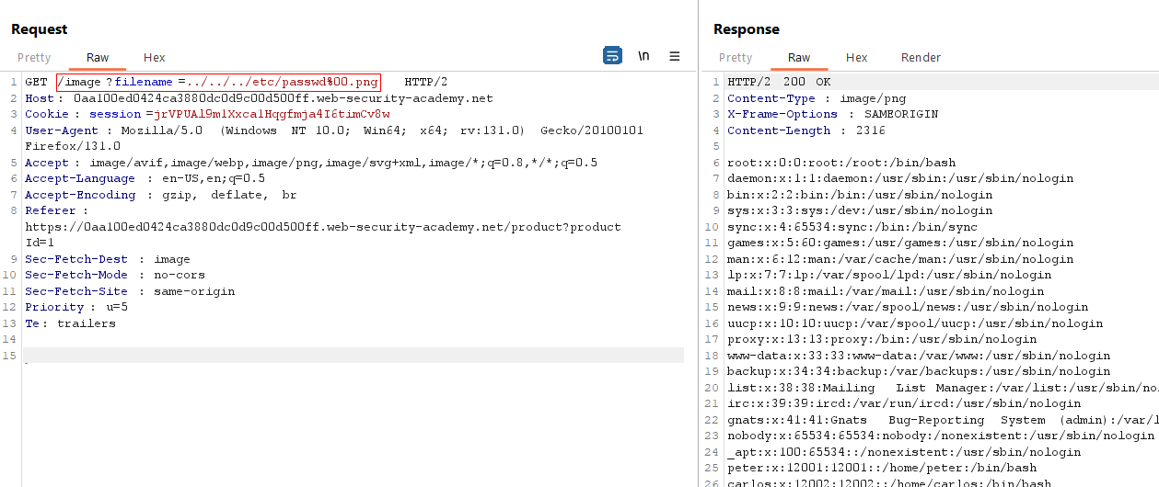

Success

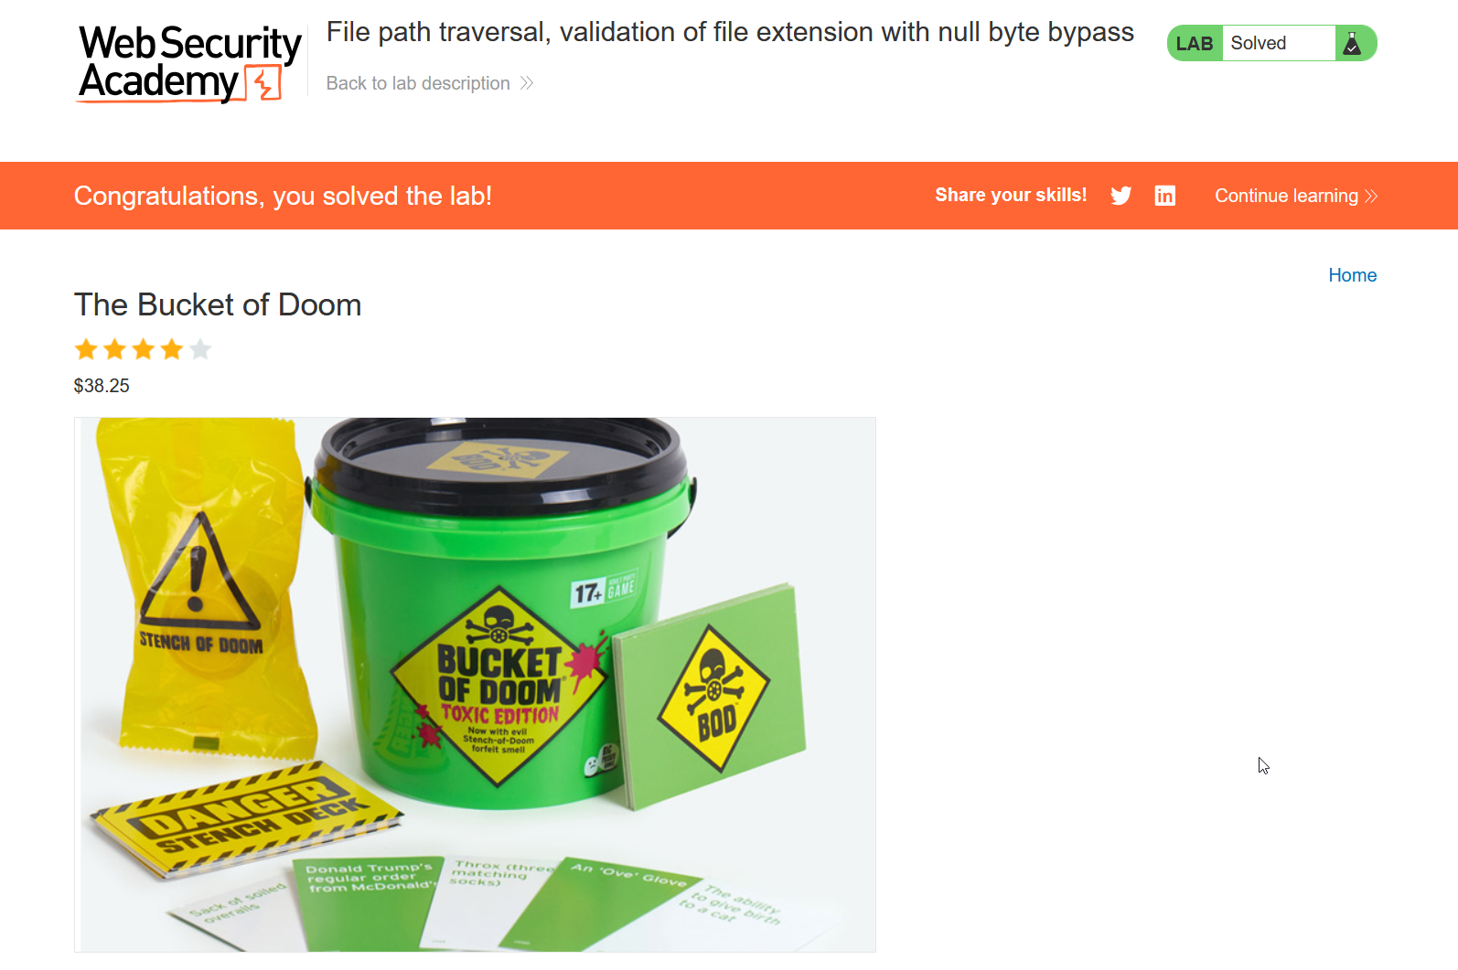

Done

**How to prevent a path traversal attack**

The most effective way to prevent path traversal vulnerabilities is to avoid passing user-supplied input to filesystem APIs altogether. Many application functions that do this can be rewritten to deliver the same behavior in a safer way.

If you can't avoid passing user-supplied input to filesystem APIs, we recommend using two layers of defense to prevent attacks:

* Validate the user input before processing it. Ideally, compare the user input with a whitelist of permitted values. If that isn't possible, verify that the input contains only permitted content, such as alphanumeric characters only.
* After validating the supplied input, append the input to the base directory and use a platform filesystem API to canonicalize the path. Verify that the canonicalized path starts with the expected base directory.

Below is an example of some simple Java code to validate the canonical path of a file based on user input:

File file = new File(BASE_DIRECTORY, userInput);

if (file.getCanonicalPath().startsWith(BASE_DIRECTORY)) {

// process file

}